# Shared Bench-Marking Steps

## Populate Database “Tpcc”

When running the relevant TPC-C application for each database system, a windows form should appear after initiating the .exe file as seen in Figure 1. The populating the database begins with the “Recreate DB” button. This opens another cmd window which displays the progress of the creation of the database Tpcc. Once the initial database structure is created and items are added, the “Add Stock” button is used to fill the stock in each warehouse. Once this is finished, “Fill District(s)” is used to complete the population of the database by filling the customer and district tables .

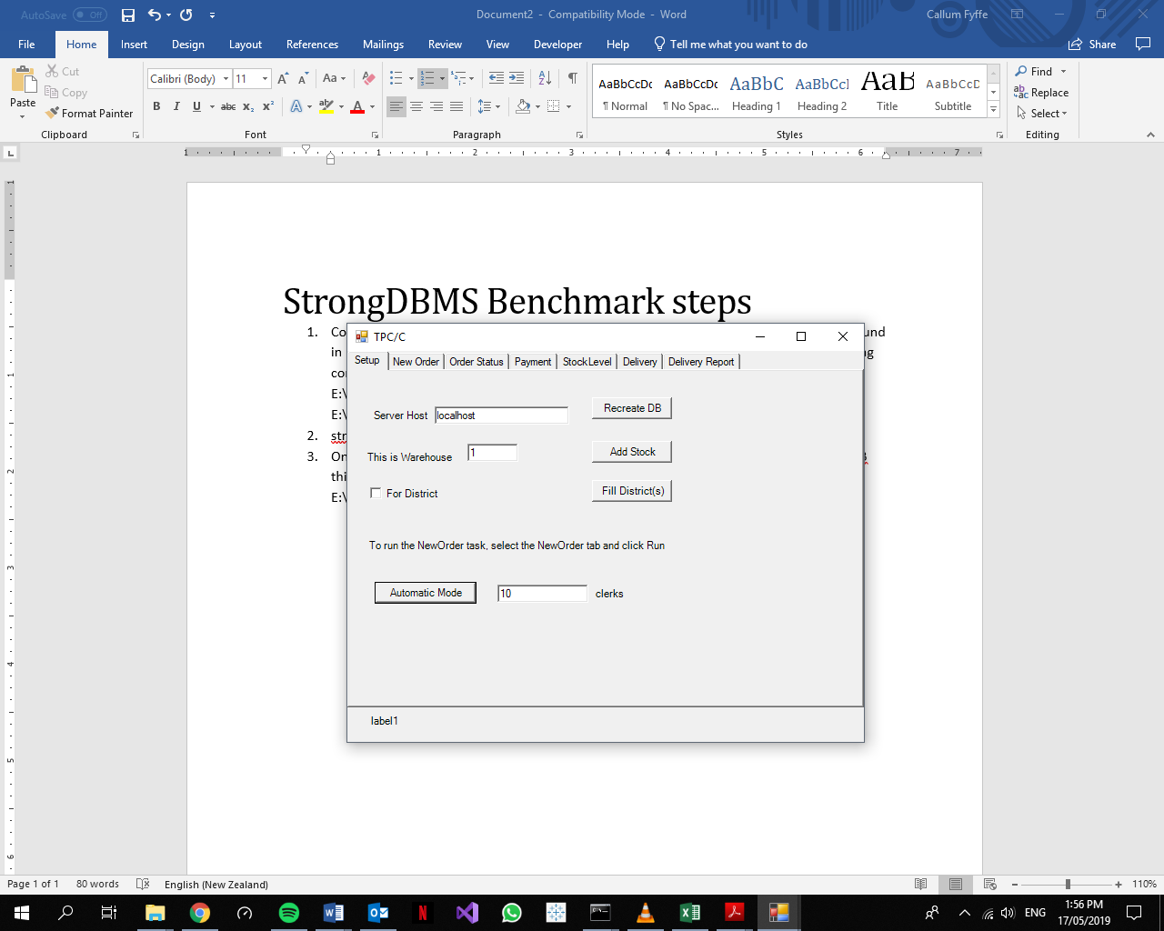

Figure 1: TPC/C Setup

Below is an example of what should appear in the TPC-C cmd prompt window when the database is populated:

**Recreate DB**Adding Items: 21/05/2019 10:56:39 AM  
Items done: Fill stock?21/05/2019 10:57:40 AM

**Add Stock**   
Starting warehouse 1 21/05/2019 10:58:12 AM  
filling stock 21/05/2019 10:58:12 AM  
Done filling stock 21/05/2019 10:59:32 AM

**Fill District(s)**Filling District 1 21/05/2019 10:59:39 AM  
starting customer w=1 d=1 21/05/2019 10:59:39 AM  
Customers done 21/05/2019 10:59:43 AM  
Done Filling District 21/05/2019 11:00:06 AM  
Filling District 2 21/05/2019 11:00:06 AM  
starting customer w=1 d=2 21/05/2019 11:00:06 AM  
Customers done 21/05/2019 11:00:10 AM  
Done Filling District 21/05/2019 11:00:34 AM  
Filling District 3 21/05/2019 11:00:34 AM  
starting customer w=1 d=3 21/05/2019 11:00:34 AM  
Customers done 21/05/2019 11:00:38 AM  
Done Filling District 21/05/2019 11:01:02 AM  
Filling District 4 21/05/2019 11:01:02 AM  
starting customer w=1 d=4 21/05/2019 11:01:02 AM  
Customers done 21/05/2019 11:01:10 AM  
Done Filling District 21/05/2019 11:01:33 AM  
Filling District 5 21/05/2019 11:01:33 AM  
starting customer w=1 d=5 21/05/2019 11:01:33 AM  
Customers done 21/05/2019 11:01:37 AM  
Done Filling District 21/05/2019 11:02:00 AM  
Filling District 6 21/05/2019 11:02:00 AM  
starting customer w=1 d=6 21/05/2019 11:02:00 AM  
Customers done 21/05/2019 11:02:05 AM  
Done Filling District 21/05/2019 11:02:28 AM  
Filling District 7 21/05/2019 11:02:28 AM  
starting customer w=1 d=7 21/05/2019 11:02:28 AM  
Customers done 21/05/2019 11:02:32 AM  
Done Filling District 21/05/2019 11:02:56 AM  
Filling District 8 21/05/2019 11:02:56 AM  
starting customer w=1 d=8 21/05/2019 11:02:56 AM  
Customers done 21/05/2019 11:03:00 AM  
Done Filling District 21/05/2019 11:03:25 AM  
Filling District 9 21/05/2019 11:03:25 AM  
starting customer w=1 d=9 21/05/2019 11:03:25 AM  
Customers done 21/05/2019 11:03:30 AM  
Done Filling District 21/05/2019 11:03:54 AM  
Filling District 10 21/05/2019 11:03:54 AM  
starting customer w=1 d=10 21/05/2019 11:03:54 AM  
Customers done 21/05/2019 11:03:58 AM  
Done Filling District 21/05/2019 11:04:21 AM

## Run Benchmark (Automatic Mode)

The “Automatic Mode” button in Figure 1 will begin the benchmark. This will simulate a number of clerks attempting to execute transactions with the Tpcc database. The cmd prompt window that opens with Tpcc.exe is designed to display statistics of the current benchmark. These include the number of clerks being used, a timestamp, the number of commits to the NEW_ORDER table, the number of read conflicts, the number of write conflicts, and a timestamp 10 minutes after the initialisation of the benchmark. Below is an example of this used on SQL Server.

E:\ShareableDataStructures-master\0.1\bin>tpccsqlserver  
Started at 27/05/2019 3:03:59 PM with X clerks  
At 27/05/2019 3:13:59 PM Commits XX, Conflicts X XX

The requests.txt file found in E:\ShareableDataStructures-master\0.1\bin should be stored somewhere else with an appropriate name (ie. “Strong_requests_10” for a 10 clerk TPC-C benchmark on Strong) so it can be analysed manually for anomalies. This must be done before another test is initialised as it will be over-written during the next benchmark. For Strong, the server must be disconnected to access the requests.txt file.